**Leader Board Research**

* *Continuously changing* top players between a few people AT LEAST (to prove its possible, you just need to put the time and effort in)
* *Time frames* Monthly ladder – weekly ladder – daily – hourly – separate leader boards depending on how regularly you are able to check your game. (Doesn’t restrict anyone – forcing people on when they can’t is bad – or at least trying to)

Games I Searched:

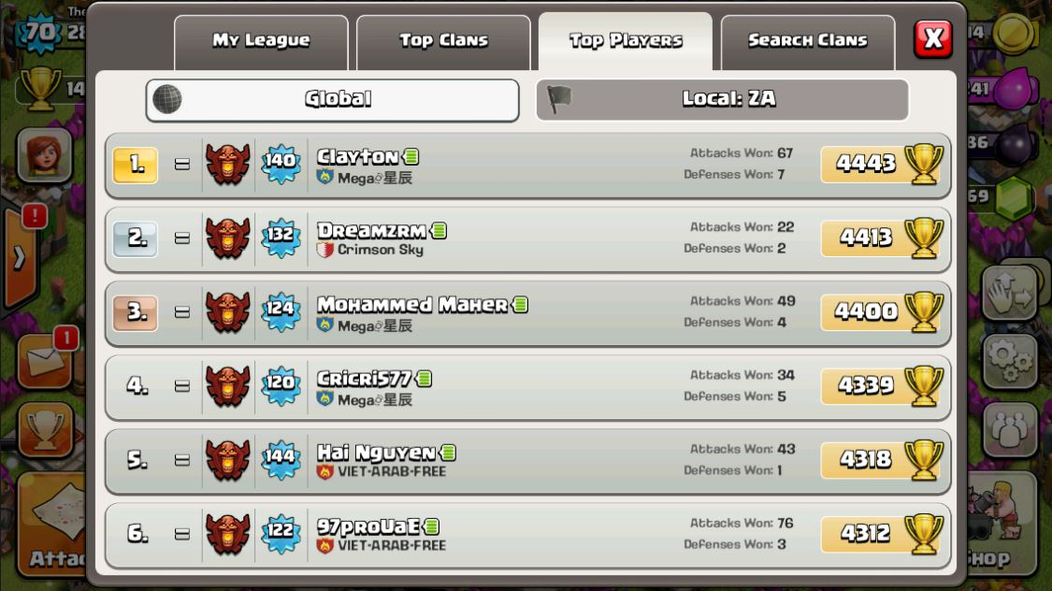

* **Clash of Clans**
* Takes only Victory stats into mind (Not only how many you’ve won but also how many defences won)

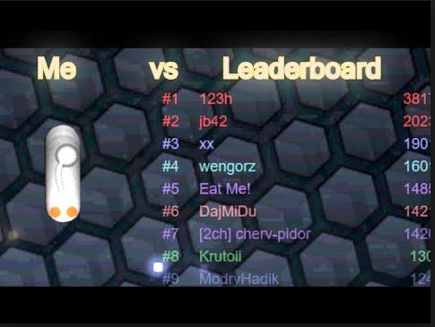

**Slither.io**

* Only one scoring system
* One leader board per server
* If you can make your snake
* Short term *attachment* between player and scoreboard
* 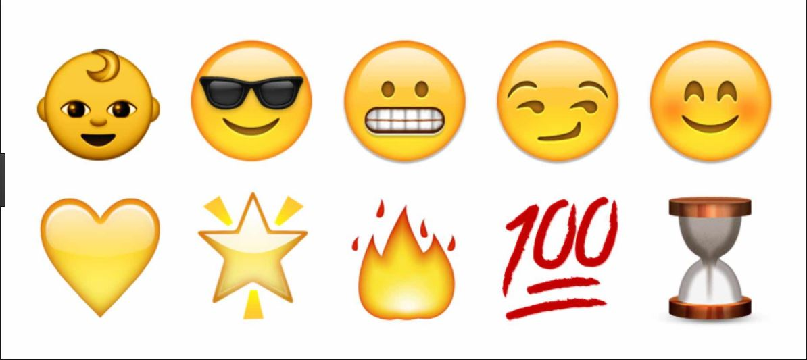Simple yet effective for short bursts of gameplay

**Snapchat:**

* Keeps people coming back like a game
* They a lot of the time even forget it is about communicating with each other
* Spamming
* Every day

**Our Leader Board:**

Based on how much Faith you can collect within certain time frames

* Monthly / Weekly / Daily / Hourly – separate leader boards
* No pay to win (clash of clans – a lot of top players if not all have paid a lot of money to speed the processes up a large amount)
* Time investment should be the key factor to being at the top